**Lab 5: Data Manipulation Languages (DML)**

**Objectives:**

The objective of this task was to perform various Data Manipulation Language (DML) operations on a database structure derived from the Northwind sample database. These operations included inserting new records into tables such as categories, suppliers, customers, products, and employees. Additionally, the task aimed to update specific records based on criteria like country and city, as well as convert data for customers from one region to another. Furthermore, the task involved deleting records from tables based on certain conditions, such as Postal Code patterns and birth months. Finally, the goal was to retrieve aggregated data, including counts of suppliers by country and customers by city, as well as order counts by employee.

1. **Data Import:**
2. **Download northwind-db.sql from classroom link**
3. **Open MySQL Workbench and Login using root or <name>**
4. **Create database <name>northwind**

**Query:**

CREATE DATABASE sulavlab5_northwind;

**Output:**

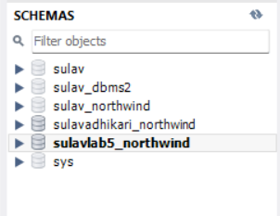

1. **Import downloaded database in sulavlab5_northwind**

**Output:**

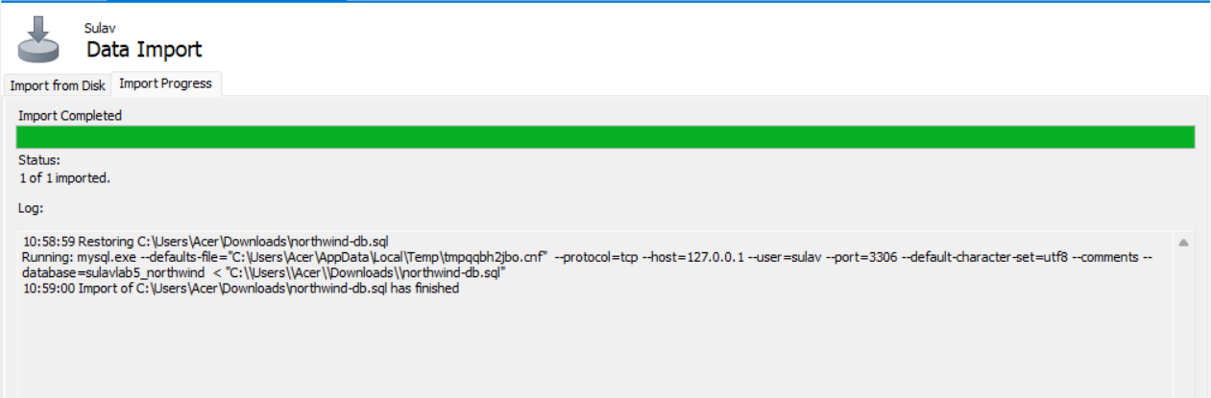

1. **Data Manipulation Languages (DML)**
2. **Add two product categories of your choice**

**Query:**

INSERT INTO categories (CategoryName, Description)

VALUES ('Confectionery', 'Sweet snacks and candies'),

('Alcoholic Beverages', 'Wines, beers, and other alcoholic drinks');

**Output:**

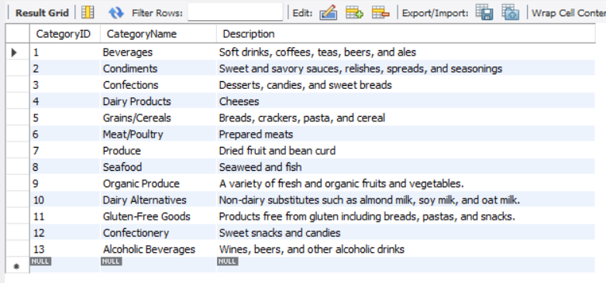

1. **Add 3 new suppliers in suppliers’ table**

**Query:**

INSERT INTO suppliers (SupplierName, ContactName, Address, City, PostalCode, Country, Phone)

VALUES ('Candy Land', 'Alice Johnson', '22 Candy St', 'London', 'SW1A 1AA', 'UK', '44-20-7123-4567'),

('Wine World', 'Bob Martin', '58 Vineyard Rd', 'Paris', '75008', 'France', '33-1-2345-6789'),

('Brewery Bros', 'Charlie Brown', '10 Ale Alley', 'Munich', '80331', 'Germany', '49-89-1234-5678');

**Output:**

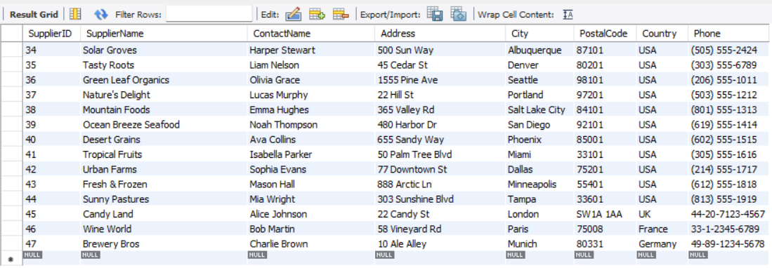

1. **Add 5 new customers in customers’ table**

**Query:**

INSERT INTO customers (CustomerName, ContactName, Address, City, PostalCode, Country)

VALUES ('John Doe', 'John', '123 Main St', 'New York', '10001', 'USA'),

('Jane Smith', 'Jane', '456 Elm St', 'Los Angeles', '90001', 'USA'),

('Michael Johnson', 'Michael', '789 Oak St', 'Chicago', '60601', 'USA'),

('Emily Davis', 'Emily', '101 Pine St', 'Houston', '77001', 'USA'),

('David Wilson', 'David', '202 Maple St', 'Phoenix', '85001', 'USA');

**Output:**

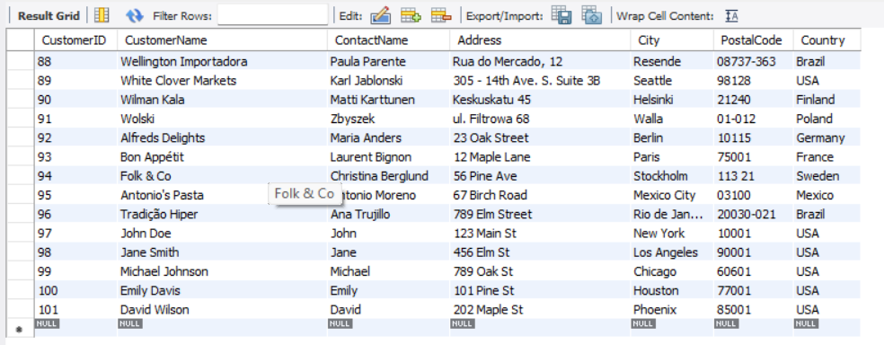

1. **Add 4 products in product table**

**Query:**

INSERT INTO products (ProductName, SupplierID, CategoryID, Unit,Price)

VALUES ('Smartphone', 1, 1, 'Piece', 699),

('Laptop', 1, 1, 'Piece', 999),

('Fiction Book', 2, 2, 'Piece', 20),

('Non-fiction Book', 2, 2, 'Piece', 25);

**Output:**

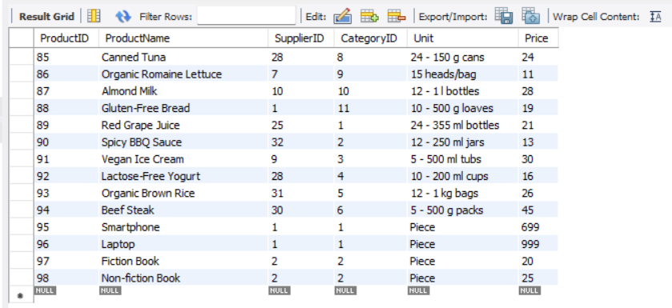

1. **Add 3 new employees.**

**Query:**

INSERT INTO employees (LastName, FirstName, BirthDate, Photo, Notes)

VALUES ('Anderson', 'Mark', '1980-05-15', 'mark.jpg', 'Notes about Mark'), ('Taylor', 'Laura', '1985-07-20', 'laura.jpg', 'Notes about Laura'), ('Brown', 'Chris', '1990-08-25', 'chris.jpg', 'Notes about Chris');

**Output:**

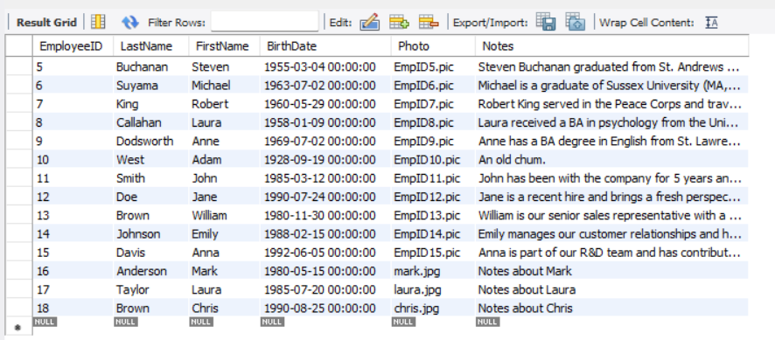

1. **Update all customers from Mexico to Vietnam**

**Query:**

UPDATE Customers SET Country = 'Vietnam' WHERE Country = 'Mexico';

**Output:**

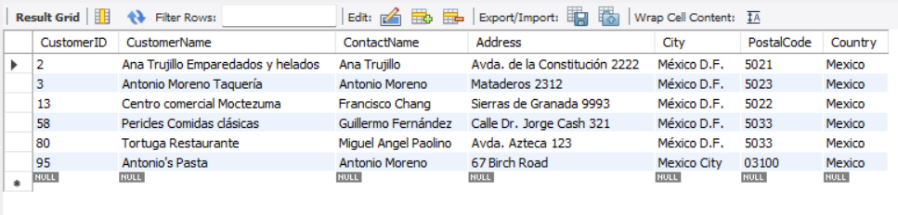

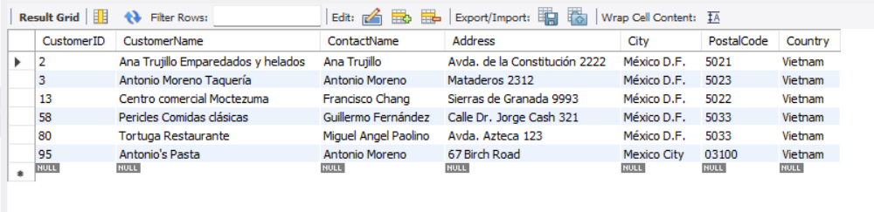

1. **Update customers table changing name of Paris City to Delhi**

**Query:**

UPDATE Customers SET City = 'Delhi' WHERE City = 'Paris';

**Output:**

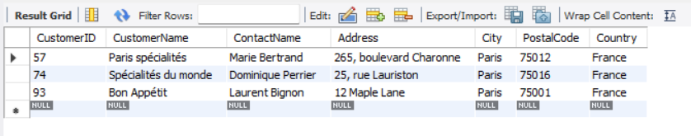

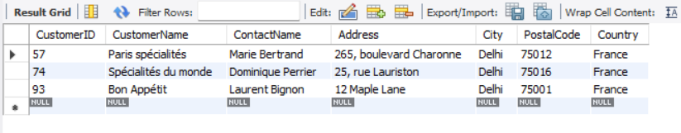

1. **Update all USA customer to Indian customers**

**Query:**

UPDATE Customers SET Country = 'India' WHERE Country = 'USA';

**Output:**

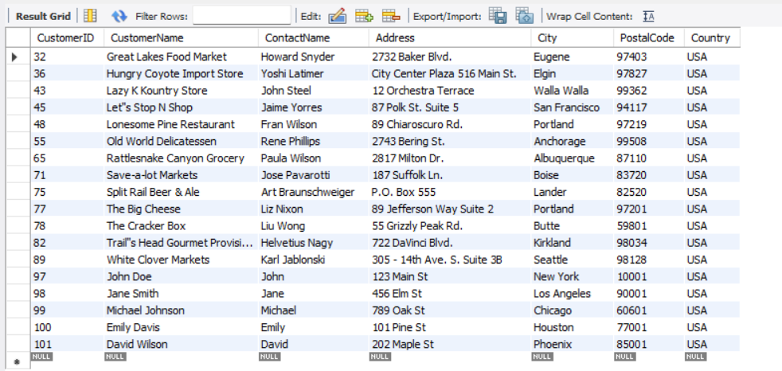

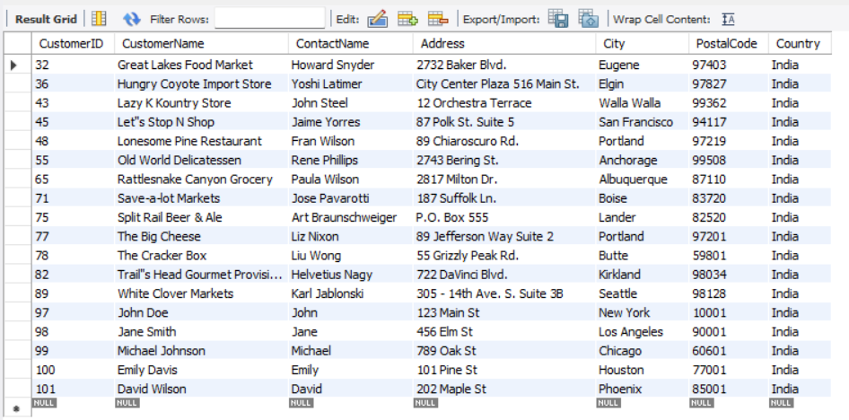

1. **Convert all Brazilian customer to Cambodian Customers**

**Query:**

SELECT * FROM customers WHERE Country NOT IN ('Venezuela', 'Argentina');

**Output:**

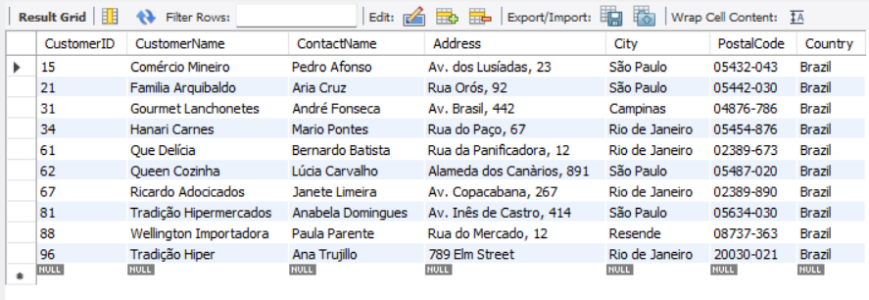

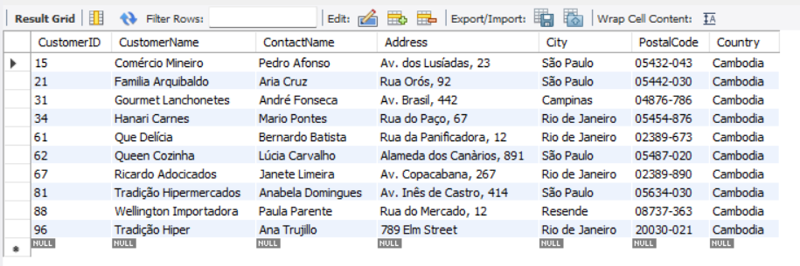

1. **Convert all customers of Madrid to Kathmandu customers also change name of country**

**Query:**

UPDATE Customers SET City = 'Kathmandu', Country = 'Nepal' WHERE City = 'Madrid';

**Output:**

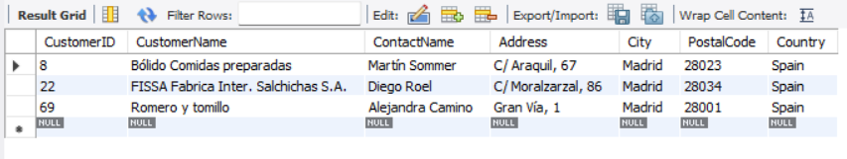

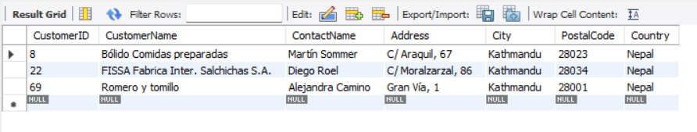

1. **Convert customers from G7 Countries to SARCC Countries**

**Query:**

UPDATE Customers

SET Country =

CASE

WHEN Country = 'USA' THEN 'India'

WHEN Country = 'Canada' THEN 'Bangladesh'

WHEN Country = 'UK' THEN 'Sri Lanka'

WHEN Country = 'France' THEN 'Nepal'

WHEN Country = 'Germany' THEN 'Bhutan'

WHEN Country = 'Italy' THEN 'Maldives'

WHEN Country = 'Japan' THEN 'Pakistan'

END

WHERE Country IN ('USA', 'Canada', 'UK', 'France', 'Germany', 'Italy', 'Japan');**Output:**

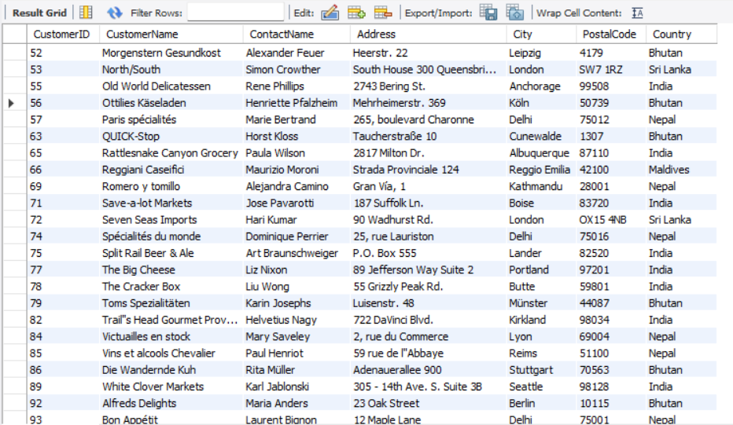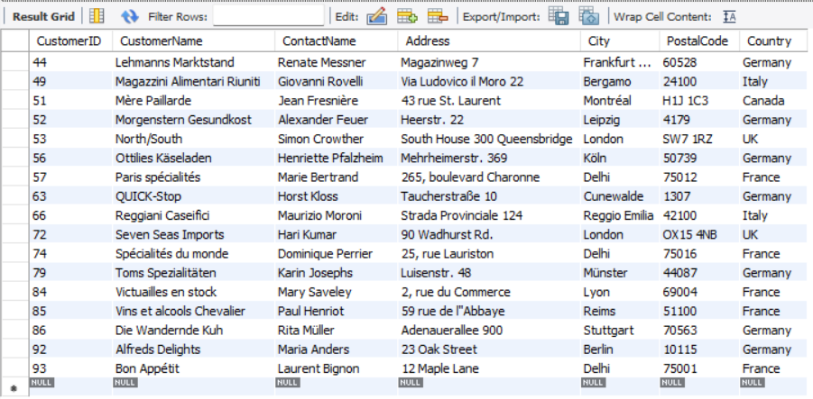

1. **DELETE all from customers who have PostalCode containing 31**

**Query:**

SDELETE FROM Customers WHERE PostalCode LIKE '%31%';

**Output:**

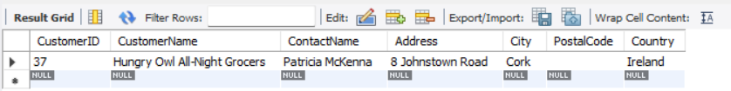

1. **DELETE all from customers having PostalCode containing 00 and from Rome or Paris.**

**Query:**

DELETE FROM Customers WHERE PostalCode LIKE '%00%' AND (City = 'Rome' OR City = 'Paris');

**Output:**

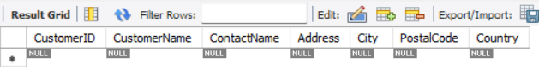

1. **DELETE all from customers who are not from Salzburg**

**Query:**

DELETE FROM Customers WHERE City != 'Salzburg';

**Output:**

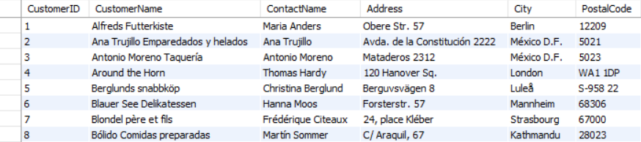

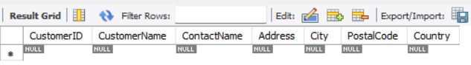

1. **DELETE all employees who are born on July**

**Query:**

DELETE FROM Employees WHERE MONTH(BirthDate) = 7;

**Output:**

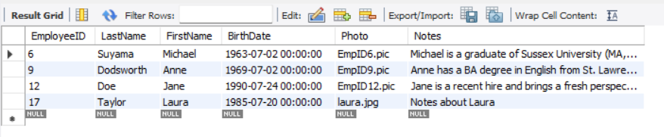

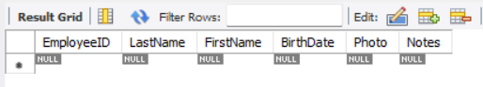

1. **DELETE all employees who are born on August**

**Query:**

DELETE FROM Employees WHERE MONTH(BirthDate) = 8;

**Output:**

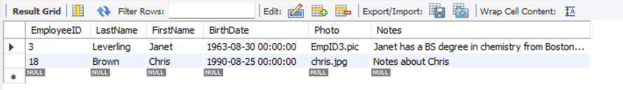

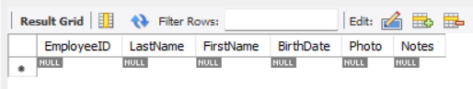

1. **DELETE all suppliers from Singapore and Japan**

**Query:**

DELETE FROM suppliers WHERE Country IN ('Singapore', 'Japan');

**Output:**

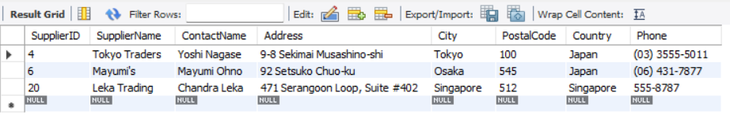

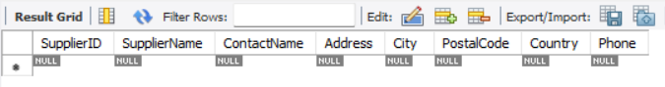

1. **Find name and count of suppliers from different countries.**

**Query:**

SELECT Country, COUNT(*) AS SupplierCount FROM suppliers GROUP BY Country;

**Output:**

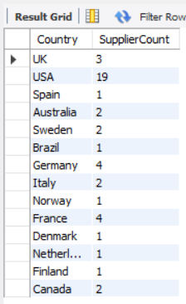

1. **Find name and count of customers from different cities.**

**Query:**

SELECT city, count(*) AS CustomerCount FROM customers GROUP BY City;

**Output:**

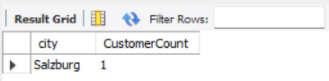

1. **Find number of orders made by employee along with employeeID**

**Query:**

SELECT EmployeeID, count(*) AS NumberOfOrders FROM orders GROUP BY EmployeeID;

**Output:**

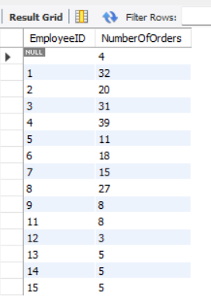

**Conclusion:**

Through the execution of these DML queries, the Northwind database was successfully manipulated to reflect new data entries and updates. The operations demonstrated the versatility and power of SQL in managing and modifying relational databases. By updating and converting customer information, the database now reflects the desired geographic and demographic changes. Deleting specific records based on targeted criteria ensured the database’s relevance and accuracy. The retrieval of aggregated data provided valuable insights into the distribution of suppliers and customers, as well as the performance of employees in terms of orders processed.